Williamsburg, First

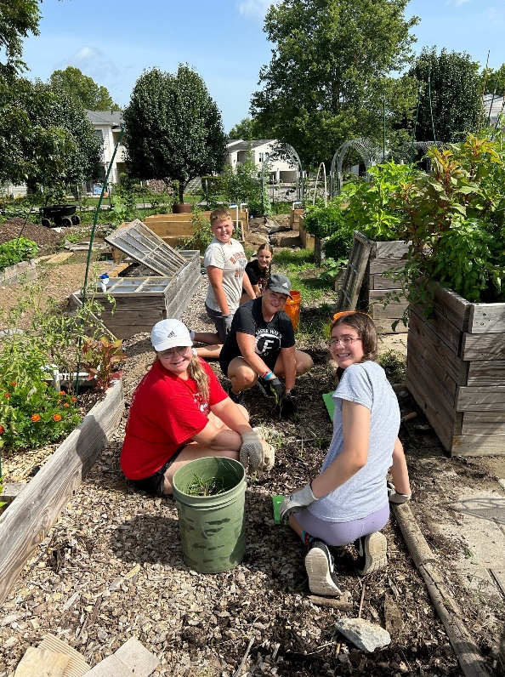
22 youth and five adults from FPC Williamsburg headed to Nashville for a week of service. The theme of the week was "Influencer" and we were challenged to find new ways of influencing culture with our verified identities in Christ. We worked at sites across the metro-area, from food banks and pantries to community gardens, baby banks, church schools, and more, doing our best to meet the needs of each program and site. The adults heard multiple times throughout the week how hard working our Iowa youth were!
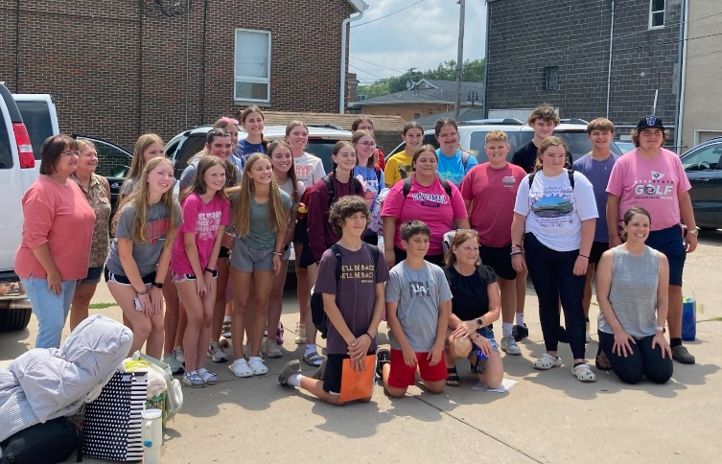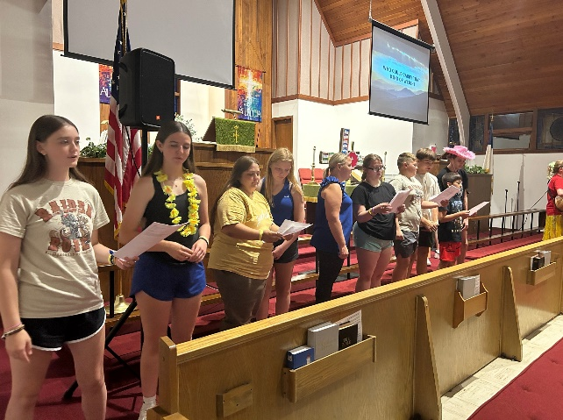

Reprinted from Out & About, August 16, 2024, the newsletter of the Presbytery of East Iowa.

